**This document is set out within a template and guide on the left to help you create an accessible document. Please read/ switch on the comments on the right hand side of the document to show tips on how to help you create an accessible document within this template.**

Title - size 24

Subheading 1 - size 18

Subheading 2 - size 14

Adding your own Subheading

Body text size 12
Lorem ipsum dolor sit amet, consetetur sadipscing elitr, sed diam nonumy eirmod tempor invidunt ut labore et dolore magna aliquyam erat, sed diam voluptua. At vero eos et accusam et justo duo dolores et ea rebum. Stet clita kasd gubergren, no sea takimata sanctus est Lorem ipsum dolor sit amet. Lorem ipsum dolor sit amet, consetetur sadipscing elitr, sed diam nonumy eirmod tempor invidunt ut labore et dolore magna aliquyam erat, sed diam voluptua. At vero eos et accusam et justo duo dolores et ea rebum. Stet clita kasd gubergren, no sea takimata sanctus est Lorem ipsum dolor sit amet. Lorem ipsum dolor sit amet, consetetur sadipscing elitr, sed diam nonumy eirmod tempor invidunt ut labore et dolore magna aliquyam erat, sed diam voluptua. At vero eos et accusam et justo duo dolores et ea rebum. Stet clita kasd gubergren, no sea takimata sanctus est Lorem ipsum dolor sit amet.

Subheading – 1 test
Lorem ipsum dolor sit amet, consetetur sadipscing elitr, sed diam nonumy eirmod tempor invidunt ut labore et dolore magna aliquyam erat, sed diam voluptua. At vero eos et accusam et justo duo dolores et ea rebum. Stet clita kasd gubergren, no sea takimata sanctus est Lorem ipsum dolor sit amet. Lorem ipsum dolor sit amet, consetetur sadipscing elitr, sed diam nonumy eirmod tempor invidunt ut labore et dolore magna aliquyam erat, sed diam voluptua. At vero eos et accusam et justo duo dolores et ea rebum. Stet clita kasd gubergren, no sea takimata sanctus est Lorem ipsum dolor sit amet. Lorem ipsum dolor sit amet, consetetur sadipscing elitr, sed diam nonumy eirmod tempor invidunt ut labore et dolore magna aliquyam erat, sed diam voluptua. At vero eos et accusam et justo duo dolores et ea rebum. Stet clita kasd gubergren, no sea takimata sanctus est Lorem ipsum dolor sit amet.

Subheading – 2 test

Duis autem vel eum iriure dolor in hendrerit in vulputate velit esse molestie consequat, vel illum dolore eu feugiat nulla facilisis at vero eros et accumsan et iusto odio dignissim qui blandit praesent luptatum zzril delenit augue duis dolore te feugait nulla facilisi. Lorem ipsum dolor sit amet, consectetuer adipiscing elit, sed diam nonummy nibh euismod tincidunt ut laoreet dolore magna aliquam erat volutpat.

Style
- For NIHR branded documents:
  - Font either Arial or Lato,
  - Title headings – size 24,
  - Subheadings – size 18,
  - Secondary subheadings – size 14,
  - Body text – size 12,
  - Text colour – black,
  - If you need to, you can set spacing in the document as well.

Tables in an accessible format

Name | Role | Telephone number
Joe Bloggs | Researcher | 0123456789
Jane Bloggs | Researcher | 9876543210
Jim Bloggs | Nurse | 0246886420

Hyperlink in an accessible format

Website link: https://cambridgebrc.nihr.ac.uk/
A screenreader will read this out word for word e.g.‘https://
Change to NIHR Cambridge BRC website
Do not use ‘Click here’ or ‘Learn more’

Pictures in accessible format

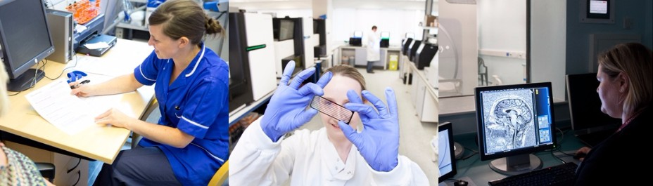

Is your document accessible?
Make sure no errors come up by going to:
- File
- Info tab
- ‘Check for issues’ and select ‘check for accessibility’
- A box will appear on the right hand side of the screen with any errors to address.

PDF your document – making it accessible

Any documents turned into PDFs, make sure the bookmarks in the PDF pane shows the correct structure you created in your Word document.

Word document
PDF
