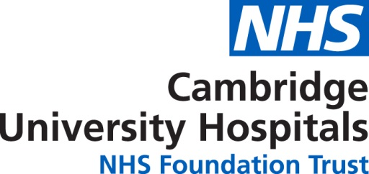

Consent to photograph, film or interview
Please complete the following information to gain consent to photograph, film or interview a patient or third party. Once completed, file under the appropriate month in the ‘Consent forms’ file.

Photography
I, the undersigned, give consent to PR & Communications at CUH to take photographs of me/my next of kin, for use in the following ways:
- internal promotion (such as our intranet, staff posters and reports)
- external promotion (such as publications, press, display material, social media)
- by our partner organisations (such as Cancer Research UK, Papworth Hospital or the BRC etc)

Interview/ filming
I, the undersigned, agree for me/my next of kin to be filmed/interviewed (delete as appropriate):
- for a TV programme, or news item (such as BBC or Anglia either TV or radio)
- for a video for training, education or recruitment purposes (by an external production company)
- as a record of treatment for monitoring purposes
- as a video record to be used for the following purpose

Name of person:
Consent given by: (either person themselves or next of kin)
Name:
Address:

Signature: Date:
Ward/department manager informed Date:
Notes:

