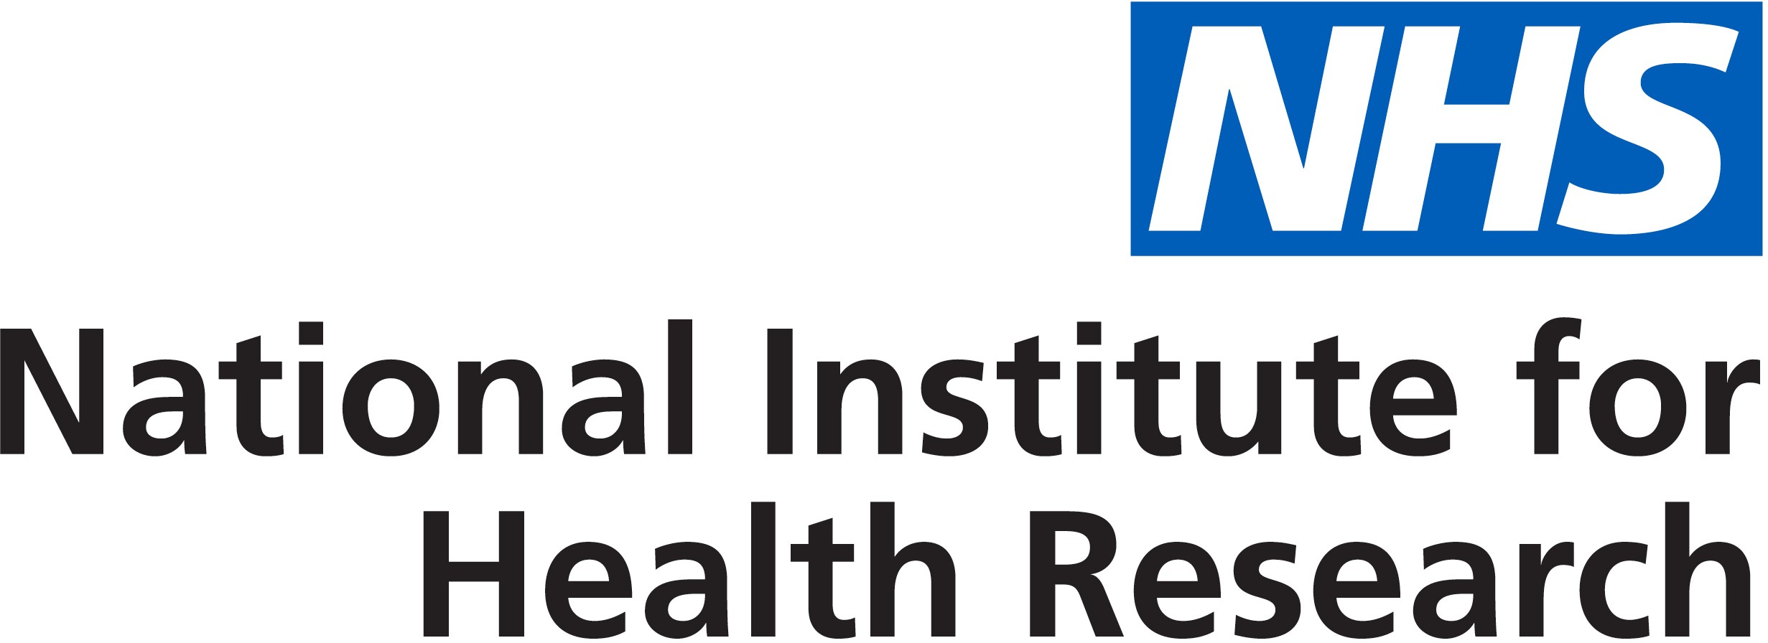

Public Open Evening on 1 November 2018

from 6.00pm to 7.30pm
doors open at 5.30pm
following the talks you can network with our researchers until 8.00pm

An open evening where leading Cambridge scientists discuss how their research is changing the future for people with conditions associated with the brain

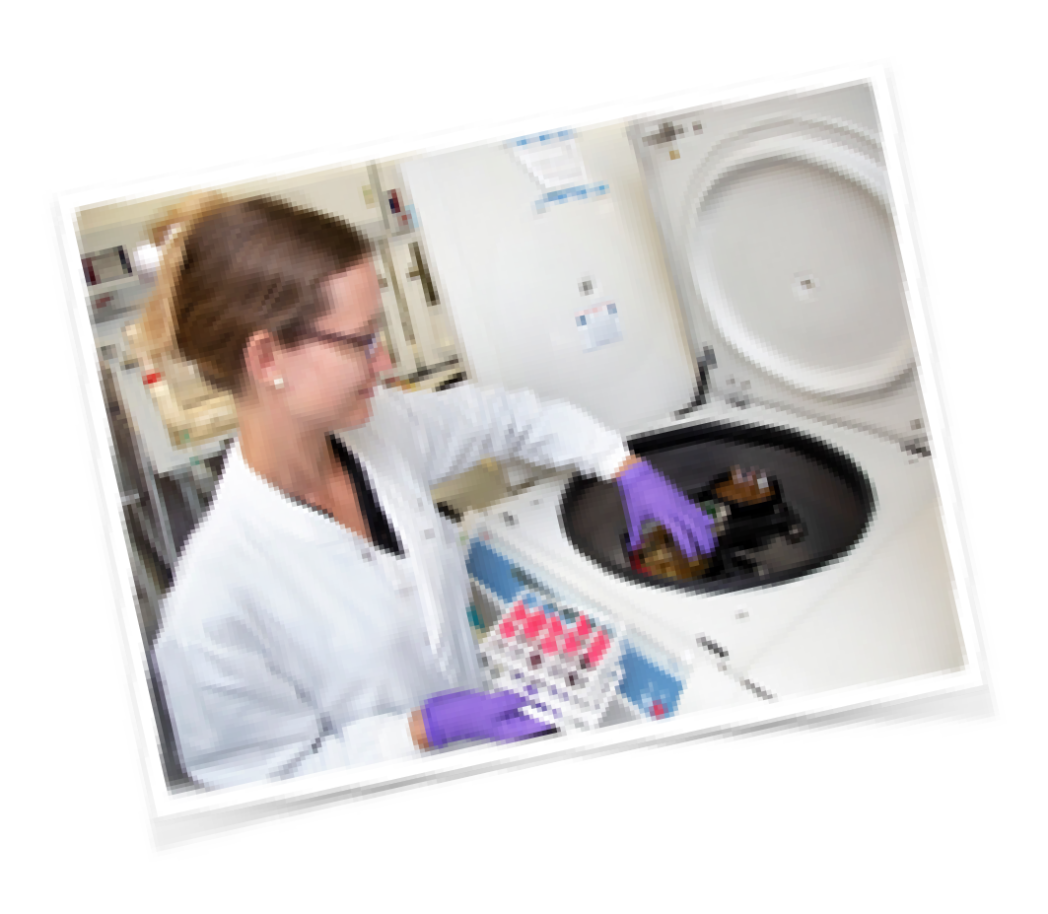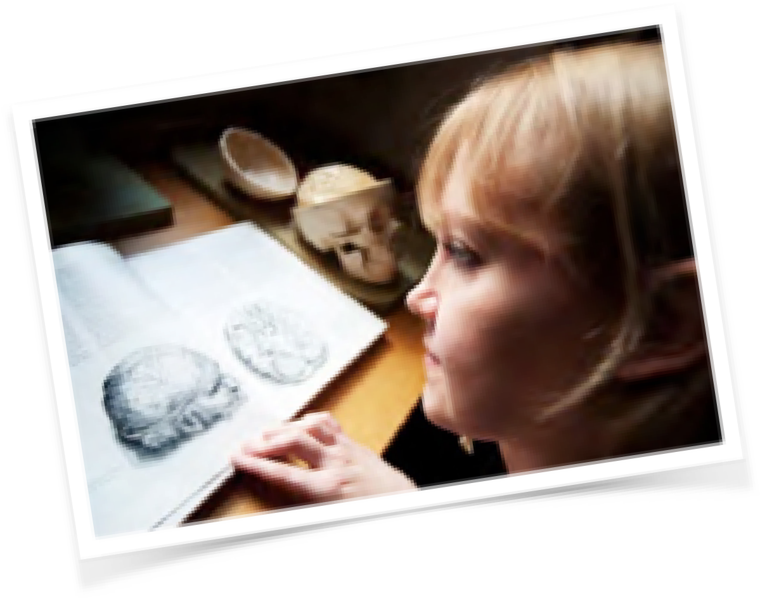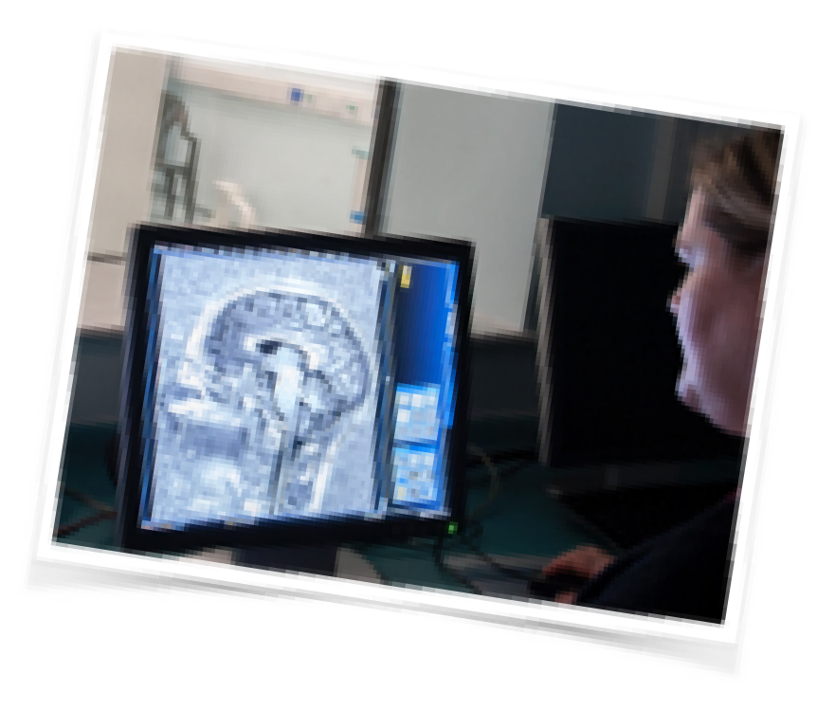How to book
Please register on Eventbrite
For any queries contact Georgina Norris
t: 01223 254608 e: gan23@medschl.cam.ac.uk

@CambridgeBRC
Venue: CRUK Cambridge Research Institute, Li Ka Shing Centre, Robinson Way,
CB2 0RE

cambridgebrc.nihr.ac.uk

